Installing Programs Through the Terminal on Ubuntu

Prerequisites: Basic Terminal Knowledge Article Type: Instructive

Installing a program on Linux is a tedious and grueling task, especially for a first time Linux user. Unlike Mac and Windows, most of the times you cannot do a simple Google search and press the download button to get the program you want. This guide will clear up the confusion with installing programs on Ubuntu-based Linux system. Without further ado, here are the three main ways to install programs.

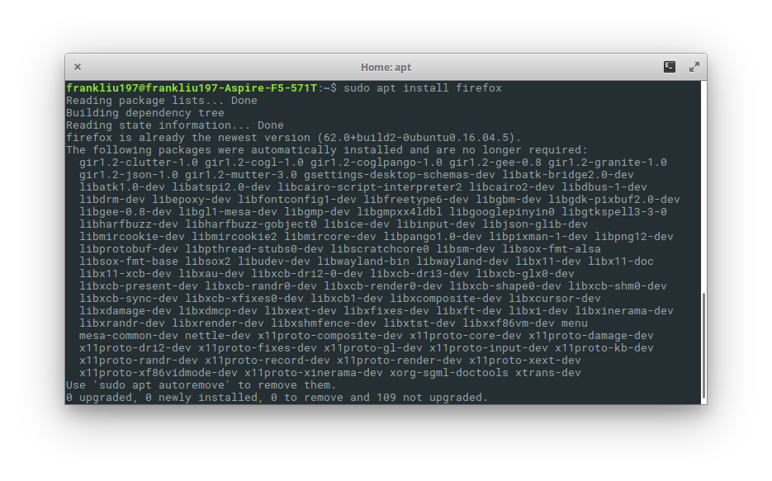

In Ubuntu, the package manager is your main tool for installing new programs. Internally, a package manager is quite complex, thus I only list basics commands required to install a program. If you want to learn the package manager more, check out my tutorial here.

For Ubuntu, your package manager is **apt**. You need to execute two commands to install a program.

$ sudo apt update

$ sudo apt install <package/program name>

The first command is for updating your package manager. It is always recommended to update it before installing a program, especially if you haven’t updated it for a while. The second command is for installing your desired program. For example, to install firefox, run:

$ sudo apt update

$ sudo apt install firefox

Sometimes, on the program’s main website, they will ask you to add a repository. Adding a repository allows your package manager to access a larger variety of software. To install a program through a repository, use the commands:

$ sudo apt-add-repository ppa:<software repository name>

$ sudo apt update

$ sudo apt install <package/program name>

Note: If you receive a “Command not Found” error with apt-add-repository, you may have to install the commandusing:

$ sudo apt update && sudo apt install software-properties-common.

2. Installing from tar, tar.gz, or tar.bz2 files

Tar files are bundles of files, like a ZIP file. To install programs from tar files, first unpack the tar file from terminal with the command:

tar xzf <tar_file>

This will create a copy of all the files in your tar file into a folder with the same name. Access the contents of the folder with the command *cd* <*folder_name*>.

For tar and tar.gz files ONLY: Look for a file with the installation instructions, which is usually named some variation of *install* or *readme*. Also check the *bin* folder. Follow those instructions and you should have no problem installing your program. In general, you look for a file named *install*, *install.sh*, *configure* or *configure.sh* and use the *./filename* command to run the file. For example, if your tar file has the file *configure*, then run the command: *./configure* to install your program.

For tar.bz2 files ONLY: Look for a file matching the name of the program inside the base directory as well as the *bin* directory. Then run the command *./filename* for that file to install the program. For example, if you are installing eclipse, you should find the file named *eclipse*, which you then install with *./eclipse*.

You can delete your tar file after installation.

1. Installing programs from deb packages

Some files you download from the internet may be packaged in a .deb file. To install a program from a .deb package, run the command:

$ sudo apt ./filename.deb

You can delete your deb file after installation.

Note: If you see a .deb file, you will most likely encounter a .rpm file. A .rpm file is for a different flavor of Linux, not Ubuntu.

If you want to learn about how to configure your installations, click here.